**List of errors and their reason**

1. **WebDriver manager dependencies is not compatibility**

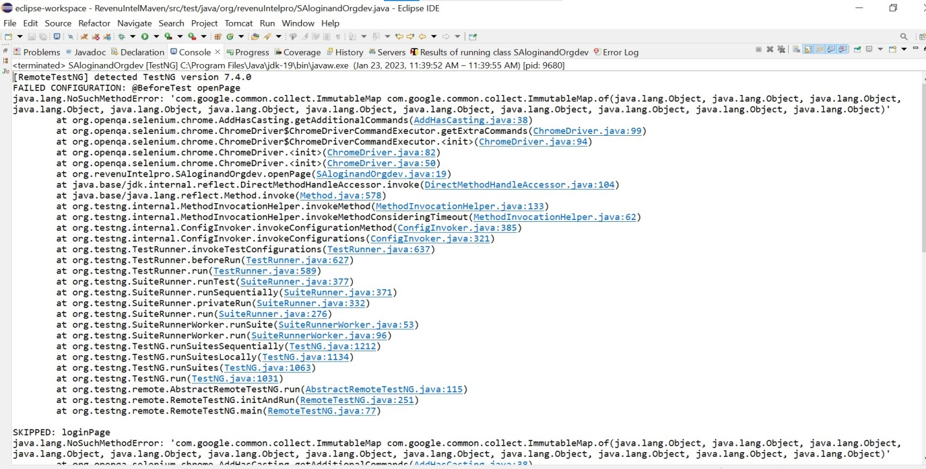

**Explanation:**

This error cause due to not added referenced libraries in buildpath.. After added selenium libraries in build path... it works.